TEMASEK POLYTECHNIC
SCHOOL OF INFORMATICS & IT

Logic and Mathematics
Tutorial 1 (Topic: Graphs)

Introduction to Graphs

1. Consider the following graph:
e₆
v₂
e₅
v₇
e₁
e₃
v₄
v₅
e₄
v₁
e₂
e₈
v₆
e₇
v₃

- Write the vertex set and the edge set.
V(G) = {v₁, v₂, v₃, v₄, v₅, v₆, v₇}
E(G) = {e₁, e₂, e₃, e₄, e₅, e₆, e₇, e₈}
- Are there any parallel edges, loops or isolated vertex?
Parallel edges = e₃, e₄
Loops = {v_{6,} v₆}
Isolated vertex = v₇

2. Consider the following graph:

Vertex set = {v₁, v₂, v₃, v₄}
Edge = {(v₁, v₂), (v₁, v₃), (v₂, v₃), (v₃, v₄), (v₃, v₁), (v₄, v₄)}

Draw two different pictorial representations of this graph.
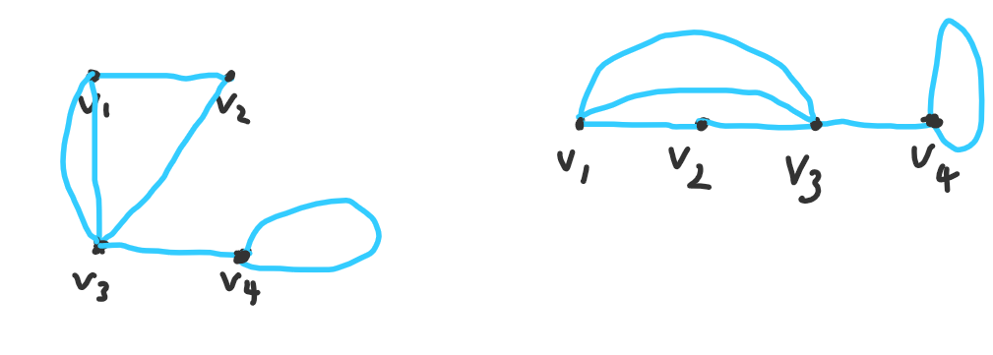
Walks, Paths and Circuits

3. In the graph below, determine if the following walks are paths, circuits or just walks. Explain your choice.
e₆
v₂
e₅
e₁
e₃
v₄
v₅
e₄
v₁
e₂
v₆
e₇
v₃

(a) v₁ e₁ v₂ e₄ v₃ e₂ v₁ – Circuit: no repeated edges, starting and ending at same vertex
(b) v₁ e₂ v₃ e₇ v₆ e₇ v₃ – Walk: repeated edges
(c) v₂ e₃ v₃ e₄ v₂ e₅ v₄ – Path: no repeated edges, doesn’t start & end at same vertex
(d) v₁ e₁ v₂ e₄ v₃ e₃ v₂ e₅ v₄ e₆ v₅ - Path: no repeated edges, doesn’t start & end at same vertex
(e) v₅ e₆ v₄ e₅ v₂ e₃ v₃ e₄ v₂ e₅ v₄ e₆ v_{5 –} Walk: Repeated edges
(f) v₆ – no walk

4. Which of the following are connected graphs? Explain.

(a) (b)
C
B
C
B

A
D
D
A

E

 | Connected? | Reason
(a) | Yes | All vertices are connected to one another by an edge.
(b) | No | A, C are isolated from B, D

End

